Year 1

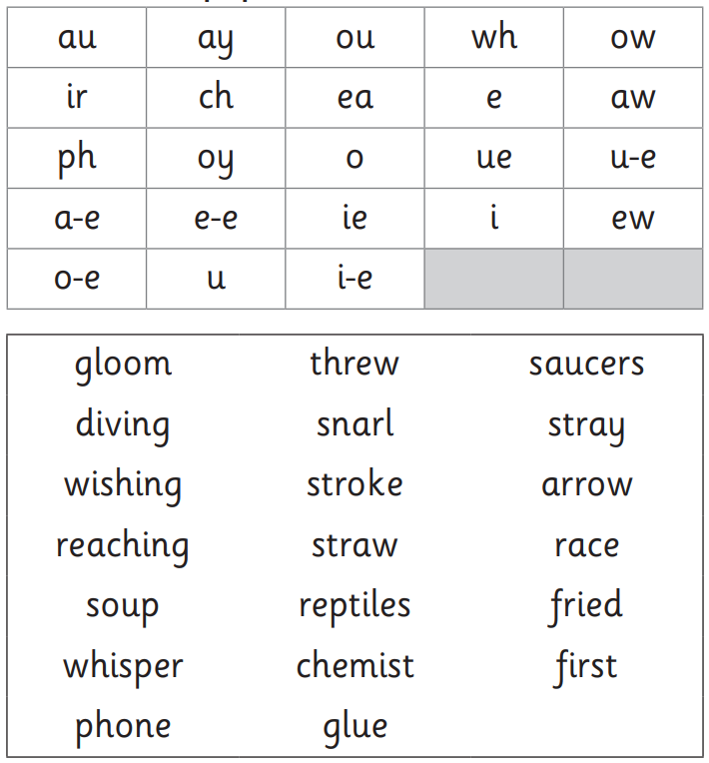

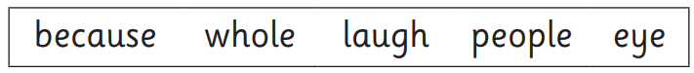

Year 2 Summer 1

circle, ice, fancy, space, dance, bicycle, silence, city,

revision, casual, confusion, version, usual, pleasure, decision, treasure,

Illness, enjoyment, plentiful, agreement, happiness, helpful, freshness, joyful,

carelessly, hopeless, lately, nicely, nosily, happily, penniless, helplessly,

I’m, it’s, I’ve, didn’t, we’ll, can’t, hasn’t, I’ll

Prickly spellings

Beautiful, laugh, busy, pretty, parents, because