Geography |  | Yorkshire | 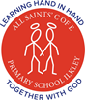  Year 4
Vocabulary |  | Counties surrounding West Yorkshire
city | A permanent and densely settled place. | 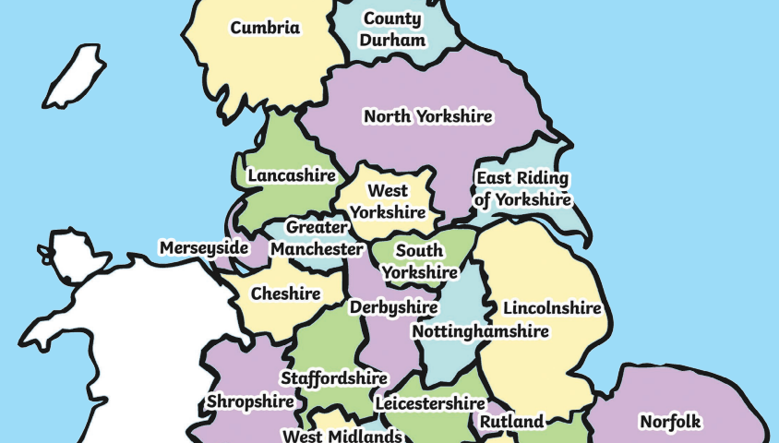 |  |  | - North Yorkshire  - East Riding of Yorkshire  - South Yorkshire  - Greater Manchester  - Lancashire  Towns and Cities  - Ilkley  - Keighley  - Saltaire  - Bradford  - Leeds
continent | A continent is one of Earth’s seven main divisions of land.
country | A nation with its own government, occupying a particular territory.
county | A territorial division of some countries.
mill | A factory where particular materials or substances are processed.
transport | A system of vehicles for getting from one place to another.
Map of Transport Links from Ilkley |  |  |  | Mill facts
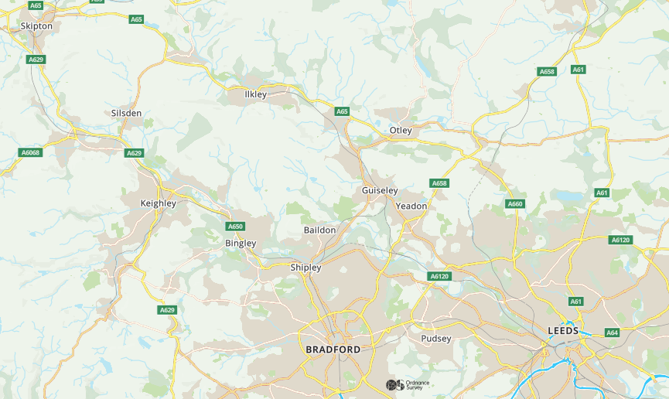
- By the 1850s around 2/3 of England’s wool was produced in Bradford.
- Cotton manufacturing began the industrial revolution in Leeds.
- Salts Mill was built by Sir Titus Salt between 1851 and 1871 to allow his workers to live in better conditions than the slums of Bradford.
- Houses, offices, shops, restaurants, art galleries and even an NHS outpatients' department are among many imaginative new uses for mills.
Roads, railways and canals are all modes of
transport close to Ilkley.

Main routes follow the valley floor for ease of
construction and travel.

Traditionally, canals were the main route for
goods transport.

Canals are now mostly a tourist and leisure
attraction.

