Science |  | Classification | Year 4
Key Vocabulary |  |   Key Knowledge
word | definition | Living things can be grouped in a variety of ways.  - Vertebrates are animals that have a spine or backbone.  - Invertebrates do not have a spine or backbone.  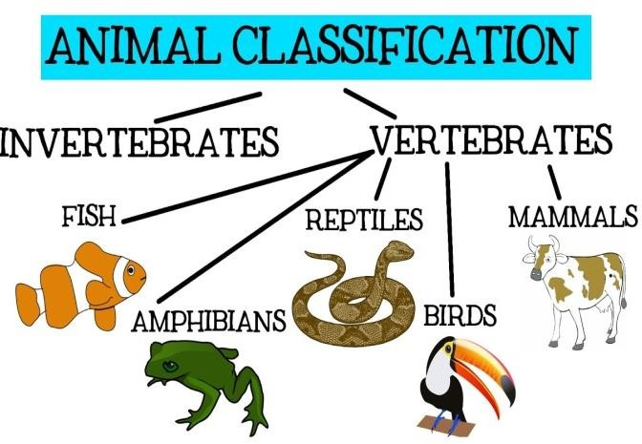  - Vertebrates can be sorted into mammals, amphibians, birds, fish and reptiles.  - Classification keys can help to groups, identify, and name a variety of living things in an environment.  - Environments can change and this can lead to living things having to change too.  A Classification Key  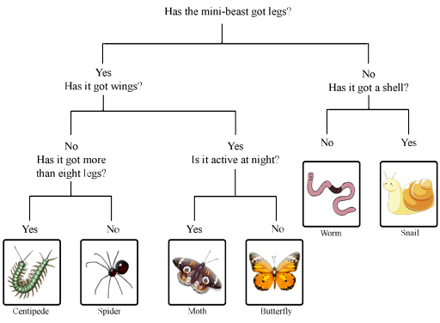
matter | Anything that has mass and volume (takes up space).
amphibian | A cold-blooded vertebrate that can live on land and in water.
classification | The process of how things are grouped according to their features.
endangered | When a species is at risk of becoming extinct.
environment | The physical surroundings in which living things  survive.
extinction | When a species no longer survives on earth – it has died out.
invertebrate | An animal without a backbone.
key | A sorting diagram used to classify and identify living things according to their features.
mammal | A warm-blooded, fur or hair covered vertebrate that feeds its young with milk, e.g. human, dogs
reptile | A scaly vertebrate that lays eggs on land, e.g. snakes, lizards.
vertebrate | An animal with a backbone.
