History |  | 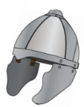  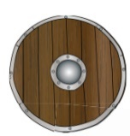  Anglo-Saxons | 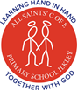  Year 5
Key Vocabulary |  | Key Knowledge/events and facts | Key People
word | definition | - The last Roman soldiers left Britain in 410 AD.  - New people came in ships across the North Sea: the Anglo-Saxons.  - The Anglo-Saxons thought the Britons were weak and easy to beat without the Romans around  - The Anglo-Saxon age in Britain was from around 410 AD to 1066.  - The Anglo-Saxons were a mix of tribes from Germany, Denmark and the Netherlands.  - The three biggest tribes were the Angles, the Saxons and the Jutes.  - The land they settled in became known as ‘Angle-land’, or England.  - Some Anglo-Saxons were warriors who enjoyed fighting.  - Some Anglo-Saxons came peacefully to find land to farm.  - Anglo-Saxon Britain tribes were not united.  - They invaded many different areas and each took over different parts of Britain. | Kings:  AD 871-899: King Alfred the Great  AD 924-939: King Athelstan  AD 1042-1066: Edward the Confessor  (AD 1050-1052: Goodwin of Wessex tried to defeat Edward)  AD 1066: Harold II
Angles | Tribes from the country that is now modern day Denmark.
Danelaw | The name given to parts of the country ruled by the  laws of the Danes.
invade | An armed force enters a country or region in order to  occupy it. |  | Invasion Map
Lindisfarne | A monastery in northern England.
Saxons | German – Dutch tribes who settled in Britain from around 450 AD. |  | 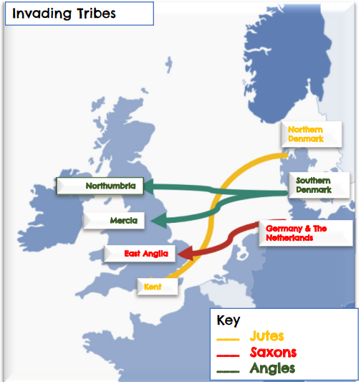
settle | To live and take up residence
thatch | The craft of building a roof with dry vegetation, such as straw.
Lifestyle
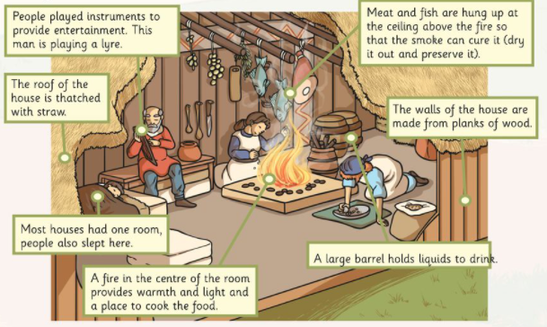 |  | Timeline
 |  | 