Science |  |  | Earth and Space |  |  | Year 5
Key Vocabulary |  |  |   Key Knowledge
word | definition |  | 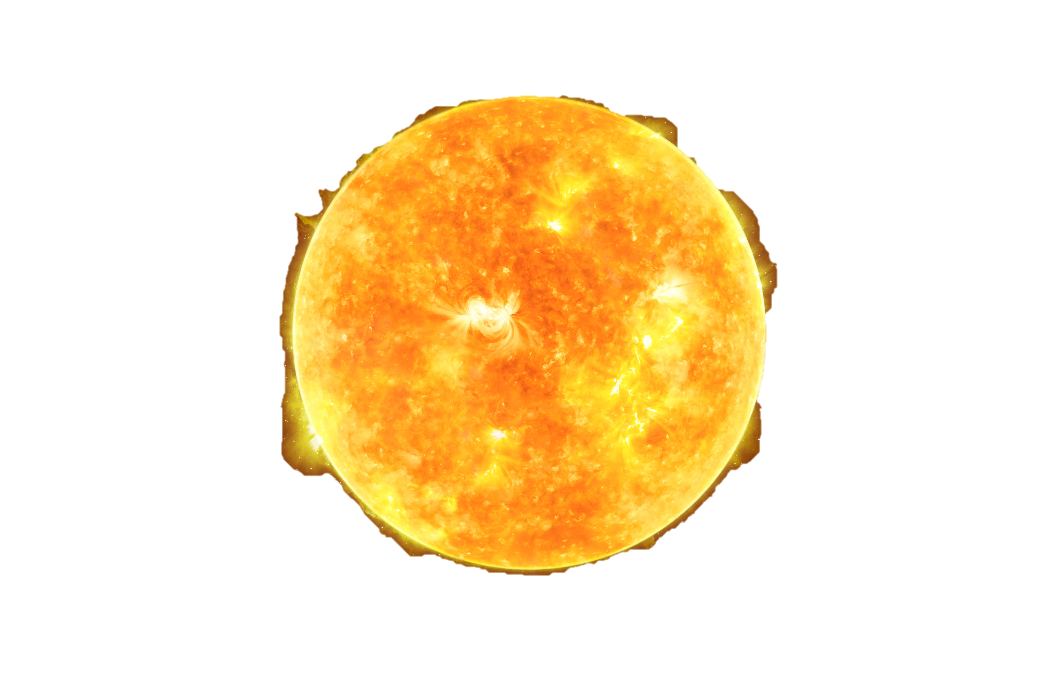  - Mercury, Venus, Earth and Mars are rocky planets, they are mostly made up of metal and rock  - Jupiter, Saturn, Uranus and Neptune are mostly made up of gases (helium and hydrogen). They do not have cores made of rock and metal  - The Sun is a burning ball of gas which appears to move across the sky during the day. However, this movement is actually due to the Earth’s orbit around the sun.  - Pluto was once known as a planet but was reclassified as a dwarf planet in 2006  - Years ago, people believed the planets moved around the Earth
matter | Anything that has mass and volume (takes up space).
axis | The (imaginary) line which a planet rotates around and tilts on.
gas giants | The name given to the four outer planets – Jupiter, Saturn, Uranus and Neptune.
geocentric | The old solar system model, which thought the earth was at the centre.
heliocentric | The modern model of the solar system, which places the sun at the centre. |  | The Solar System: 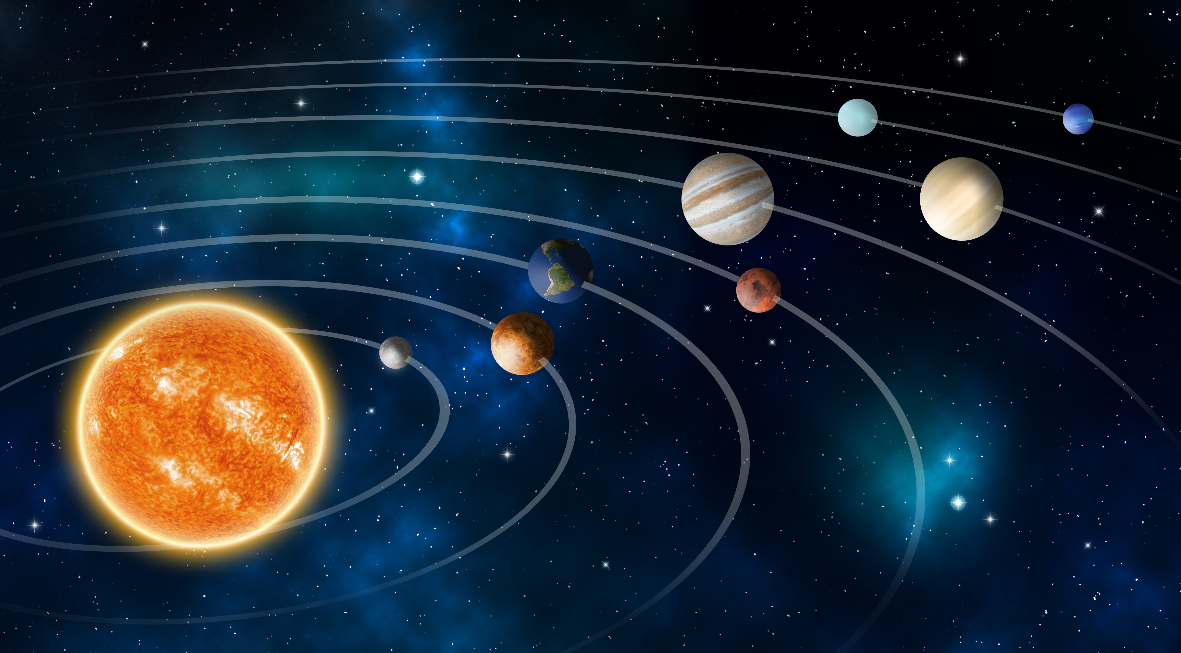  Mercury  Venus  Earth  Mars  Jupiter  Saturn  Uranus  Neptune |  | 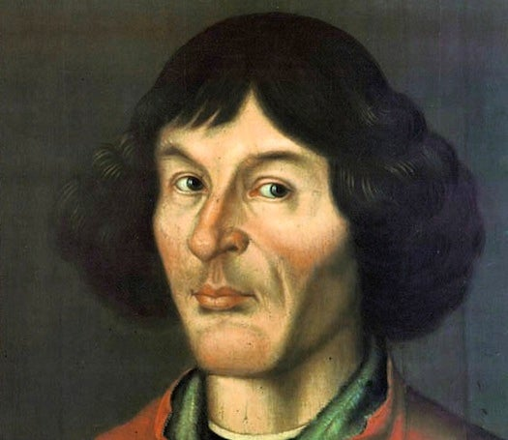  Copernicus:  - Copernicus developed the heliocentric theory that the sun was at the centre of the solar system.  - The planets orbit the sun in a circular pattern.  - Each planet has its own characteristics and features.  - The four inner planets are the rocky terrestrial planets.  - The four outer planets are the gas giants.
moon | A body which orbits a planet; also called a natural satellite.
orbit | The path of a celestial object around another, such as Moon around the Earth.
phase | The appearance of a moon or planet according to the amount of illumination.
terrestrial planet | The name given to the four inner rocky planets – Mercury, Venus, Earth and Mars.
waning | The name given to the moon phases when the moon is becoming darker.
waxing | The name given to the moon phases when the moon is becoming brighter.
The moon orbits Earth in an oval pattern whilst spinning on its axis. The sun illuminates the Moon. The shadow of the Earth creates the moon’s phases. |  | 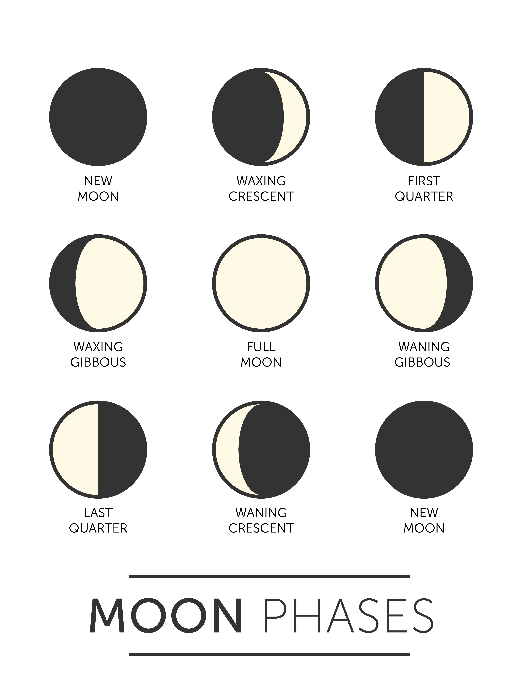 |  | 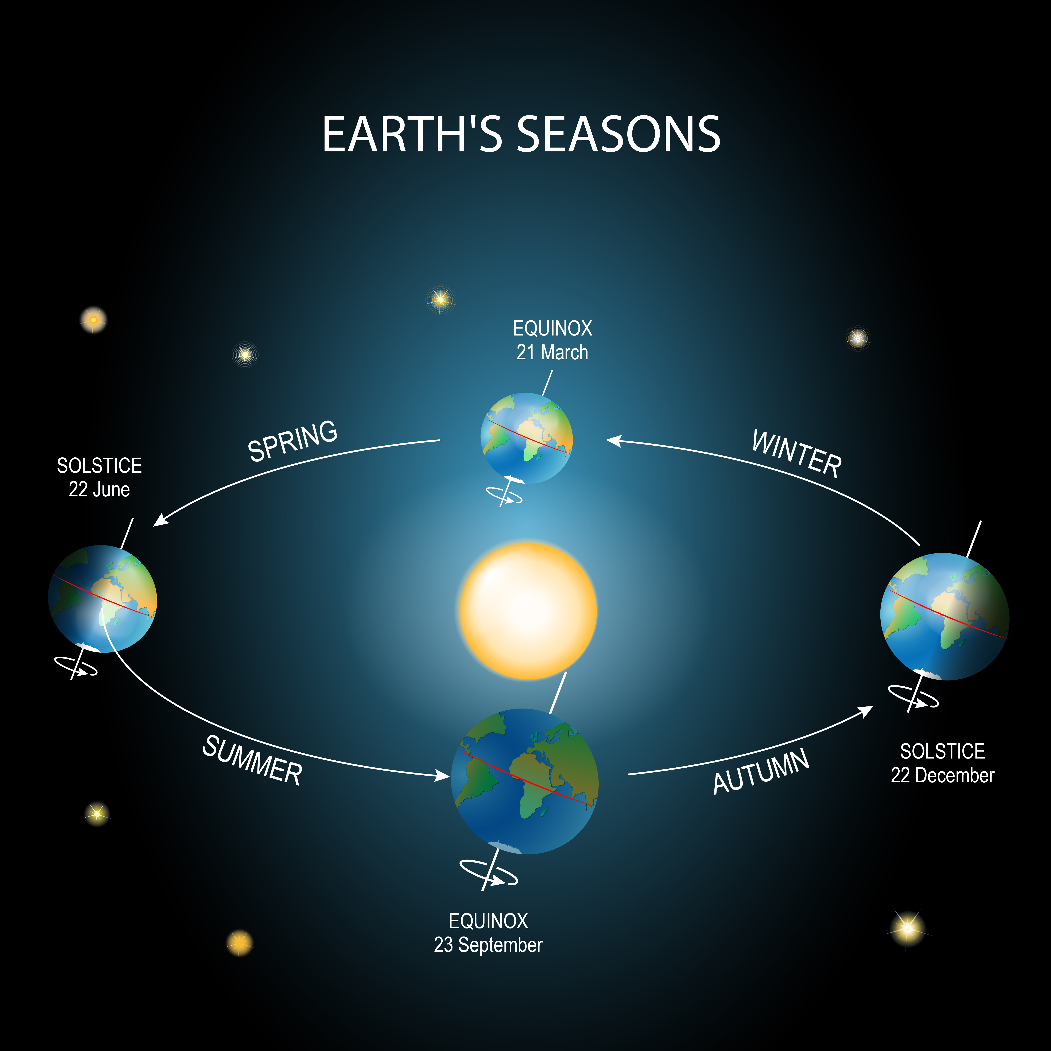  The Earth spins on its axis and completes a full rotation every 24 hours. The Earth is constantly rotating and orbiting the Sun - which takes 365 days.  As the Earth rotates, it faces towards and away from the Sun. This creates the day and night cycle.

