Science |  | Habitats around the world |  |   Year 1 & 2
Key Vocabulary |  | Key Knowledge and facts
word | definition | - There are many habitats – forests, deserts, grasslands, mountains and oceans.  - A habitat must provide everything that an organism needs to survive – food, water and shelter.  - Many mini beasts - small creatures like insects, worms or spiders - live in many microhabitats.  - Microhabitats could be tree holes, logs, under rocks and leaf litter.  - Ocean - a very large area of sea; they cover 70% of the world's surface  - Rainforest - a forest in a tropical area that receives a lot of rain  - Desert - an area, often covered with sand or rocks, where there is very little water and not many plants  - Many habitats and organisms are in danger due to litter, pollution and deforestation. |  | 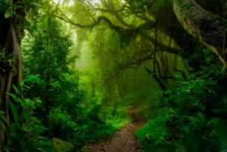  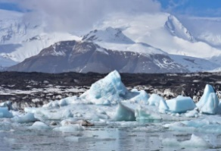  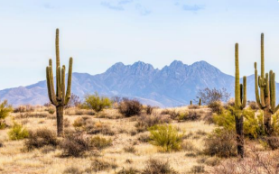  Habitats  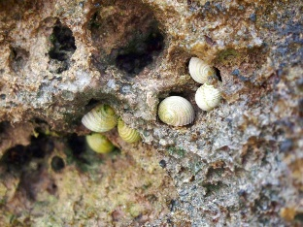  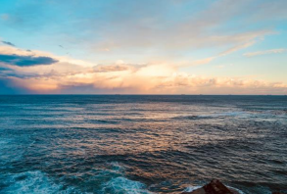  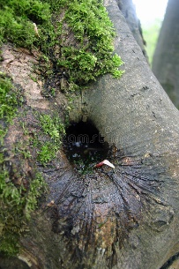  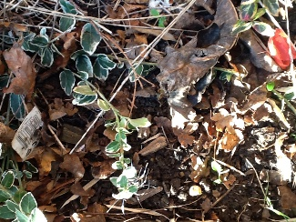  Micro habitats
biodiversity | a variety of plant and animal life in a particular habitat or place
ecosystem | an area where animals and plants live, and where they rely on one another to survive
environment | the surroundings or conditions that a living organism finds themselves in
endangered | animals or plants that may soon not exist because there are very few left
habitat | a place where living organisms live
organism | a living thing made up of one or more cells ( animals, plants)
microhabitat | A very small part of a habitat -which differs from the surrounding habitat
pollution | waste that is disposed of into the environment

Habitats in Danger

Rainforest Ocean Causes of habitat loss

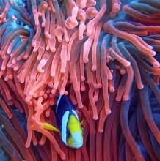  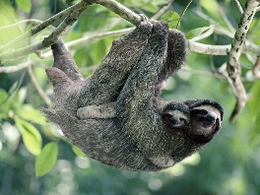  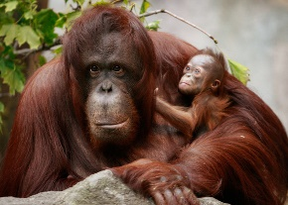  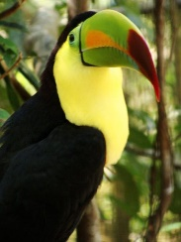  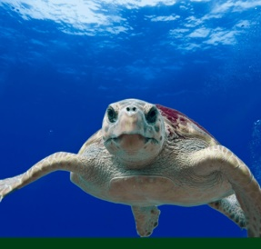  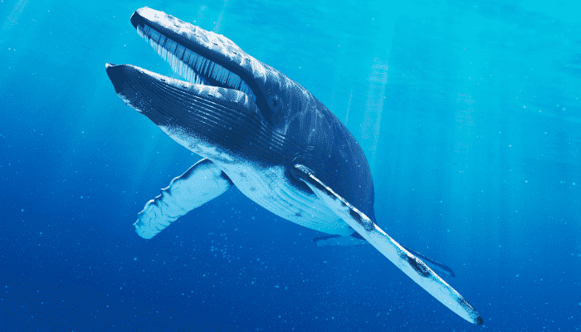 |  |  | 