Science |  | Changes of materials | Year 5
Key Vocabulary |  | Key Knowledge
word | definition | 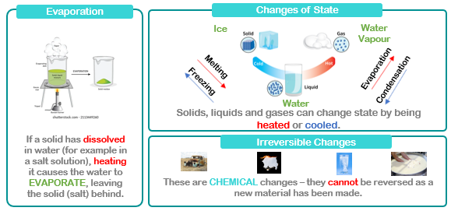
matter | Anything that has mass and volume (takes up space).
Carbon dioxide | gas which makes up around 0.04% of our atmosphere
Chemical change | a type of change in which a new substance is formed
Combustion | an irreversible change where a fuel uses oxygen to burn and releases energy
Corrosion | the reaction of a metal with oxygen
Effervescence | fizzing or bubbling
Evaporate | the process where a liquid changes to a gas
Extinguish | to put out a fire
Fair test | an experiment that only changes one variable
Reaction | process in which substances are converted into different substances
Reversible | a change to a substance that can be undone or reversed
Solute | a substance that can be dissolved in liquid
Solvent | a substance that can dissolve in a solute
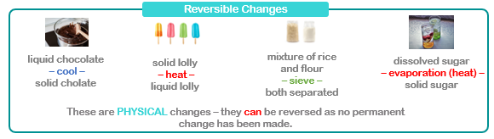
Careers connected to changes of materials:
Laboratory technicians, technical associates, research analysts, chemistry teachers

