Geography |  | Rivers | Year 5
Key Vocabulary |  | 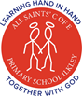  Key Knowledge
word | definition | 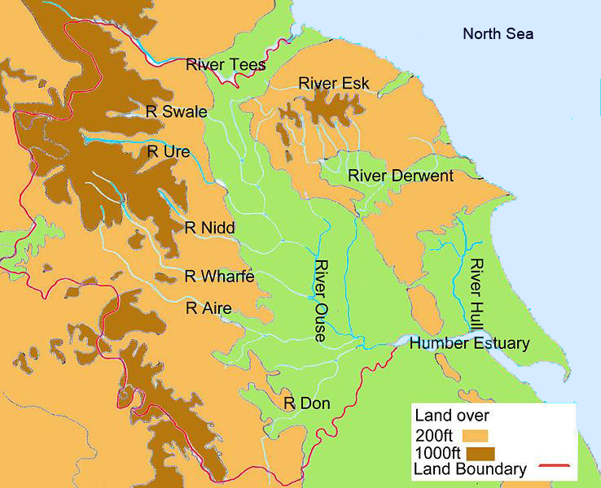  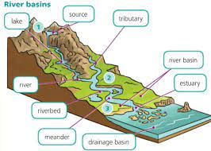  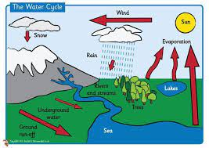  Water flows from rivers to the ocean and sea  Lots of animals live in rivers  Rivers can flood if there is a lot of rainfall  The start of a river is called the source  The end of a river is called a mouth  The longest river in the world is the River Nile  The UK’s biggest river is the Severn and the second longest is the River Thames  Rivers can create canyons, waterfalls and lakes  Rivers have currents and can be dangerous
matter | Anything that has mass and volume (takes up space).
erosion | moving water or wind causing tiny pieces of the Earth's surface to be moved from one place to another
source | the point at which a river starts
upper course | the first stage of a river, often located on high ground
middle course | the second stage of a river, where the land is flatter and the river wider
lower course | the land is flat, and the river is at its widest
valley | an area that lies between ranges of hills or mountains that a river flows through
silt | solid, dust-like sediment that water, ice and wind transport and deposit
tributaries | small streams that join the larger river
meander | the natural bend in a river
oxbow lake | a section of a meander that becomes isolated from the main river channel and eventually dries out
mouth | the point where the river ends
estuary | the point where the river meets the sea in the lower course | 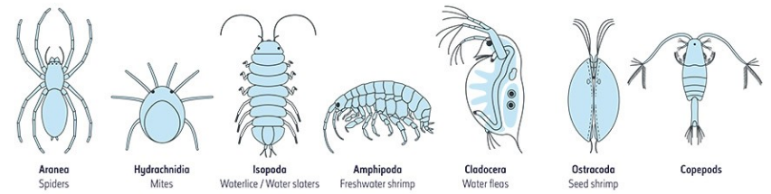
floodplain | a flat area surrounding a river or stream
delta | a wetland area that forms as river waters empty into a larger body of water
channel | the river bed and banks in which a river flows

